Pinnacle HotScript for Creating a Single PDF
Created | 04/23/09 | Created By | Jimmy Jones
Last Revised | 06/07/10 | Revised By | Nathan Childress
Last Approved |  | Approved By

Purpose
This is the procedure for creating a PDF file from a Pinnacle treatment plan. The PDF file will automatically be transferred to the specified FTP server. This procedure only works if the patient has a MRN.

Preparing for the Hot Script
- Prior to pressing the PDF Print hot script your plan should be finalized and all necessary information you wish to include in the PDF should be in its final format. For example, create your viewing windows for the DRRs, Isodoses, and DVHs.

- DRR note: All DRRs should be contained within a single viewing window. If more than one window is needed, additional windows must be printed as a ‘miscellaneous’ window.
- DVH note: Prior to running the script be sure that the correct trial is displayed and all the ROI structures you wish to include in the DVH are turned on.

- Minimize the viewing windows
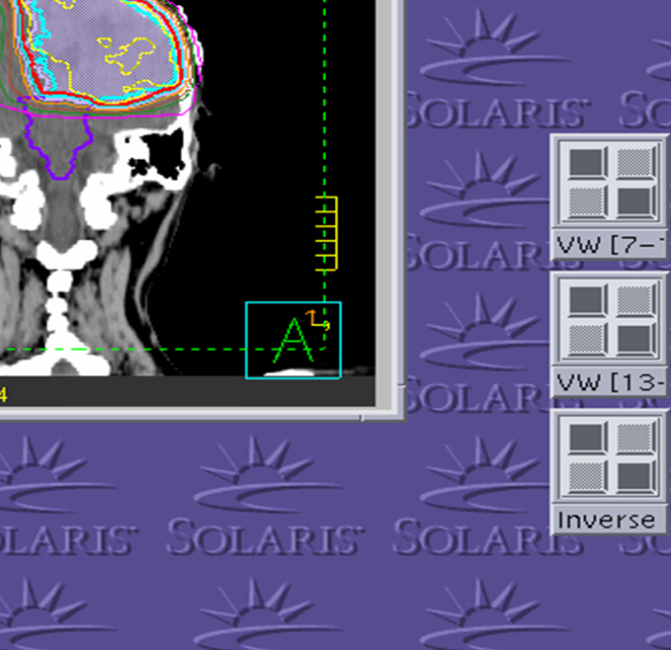
DRR viewing window minimized
Isodose viewing window minimized
DVH viewing window minimized

- Press the PDF Print button in the HotScripts window
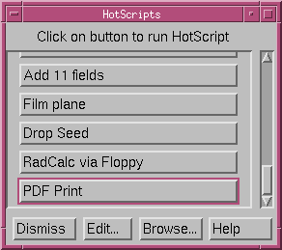

The Hot Script
- When you press the PDF Print button a Warning Message window will appear telling you to prepare the Isodose, DRR, and DVH viewing windows. These windows must be displayed and minimized before continuing the script. You will not be able to manipulate the individual viewing windows once the script begins

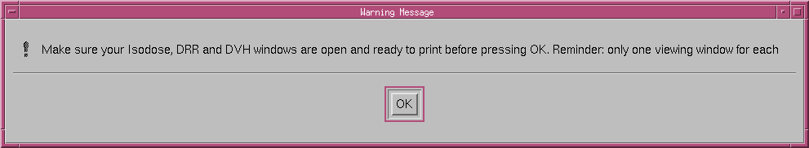

- Select OK from the initial Warning Message window
- The hot script will now create the plan summary. This process may take a few minutes.

Note: Information included in the plan summary includes beam info, ROI info, and an IMRT summary. If the system does not have an IMRT license, a warning message will appear that indicates the IMRT summary will not be printed. This will not affect the rest of the script. Press OK when the message appears.

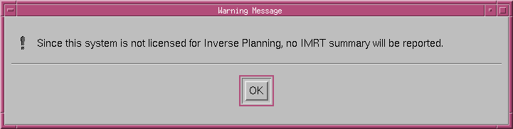

- A Yes/No Question window will appear to initialize printing of the isodose viewing window once the plan summary is finished printing.

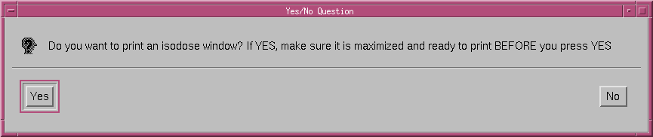

- You must maximize the isodose viewing window prior to clicking Yes. Once maximized press Yes.
- When the mouse cursor changes from an ‘arrow’ to an ‘eye’ click anywhere in the isodose viewing window.
- A Yes/No Question window will appear indicating that the report requires 1 page. Press YES to continue.

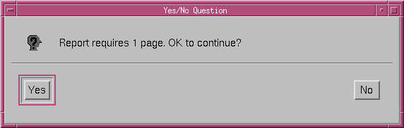

- A Yes/No Question window will appear to initialize printing of the DRR viewing window once the isodose viewing window is finished printing.

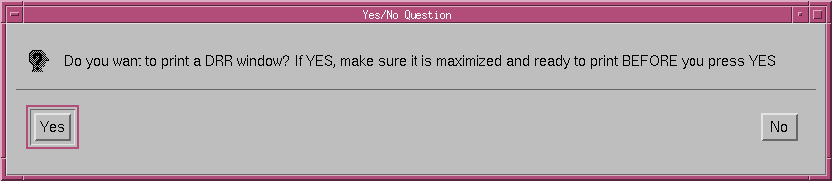

- You must maximize the DRR viewing window prior to clicking Yes. Once maximized press Yes.
- When the mouse cursor changes from an ‘arrow’ to an ‘eye’ click anywhere in the DRR viewing window.
- A Yes/No Question window will appear indicating that the report requires 1 page. Press YES to continue
- A Yes/No Question window will appear to initialize printing of the DVH viewing window once the DRR viewing window is finished printing.

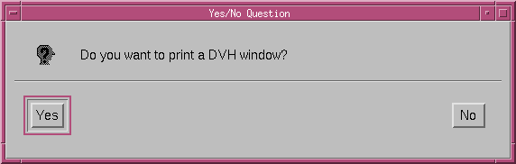

- The DVH viewing window will maximize automatically. Press YES.
- When the mouse cursor changes from an ‘arrow’ to an ‘eye’ click anywhere in the DVH viewing window.
- A Yes/No Question window will appear indicating that the report requires 1 page. Press YES to continue.

NOTE: Some plans contain numerous ROI Statistics that will not fit within a single page. If you need additional DVH plots in order to view all ROI Statistics, there is the option to print a second and third DVH window. If you do not need additional DVH plots simply press No and bypass steps 17- 27

- A Yes/No Question window will appear to initialize printing of the second DVH viewing window once the first DVH viewing window is finished printing

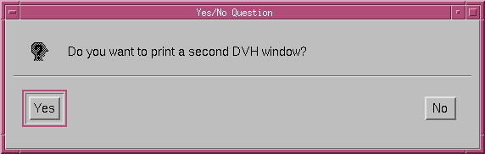

- Press Yes
- A Warning Message window will appear.

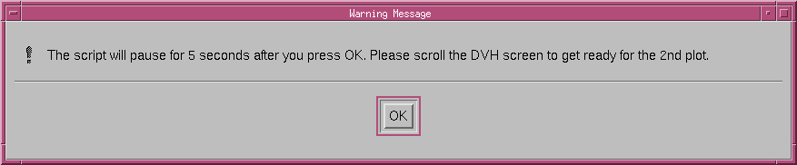

- Once you click OK to this warning message the hot script will pause for five seconds. This will give you ample time to scroll down to include previously hidden ROI Statistics.

NOTE: Mouse click the grey area beneath the scroll bar under ROI Statistics ONCE during the five second delay (see below). You will not be able to see how far you scrolled until the hot script resumes after the five second delay. If you mouse click the grey area only ONCE it will page down the proper amount so that no information is lost.
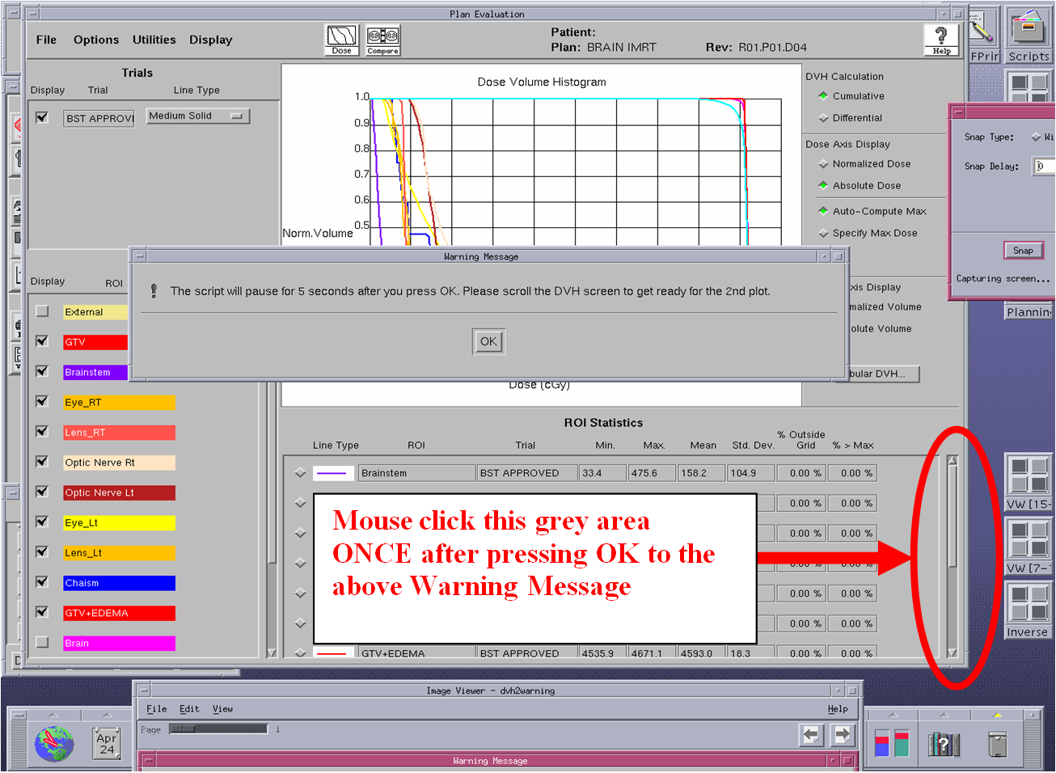

- After the five seconds, the screen will refresh and the mouse ‘arrow’ will morph into the mouse ‘eyeball’. Mouse click anywhere within the DVH viewing window when this occurs.
- A Yes/No Question window will appear indicating that the report requires 1 page. Press YES to continue.
- A Yes/No Question window will appear to initialize printing of the third DVH viewing window once the second DVH viewing window is finished printing. This DVH plot is only needed if there is still grey beneath the scroll bar indicating there are additional ROI Statistics that have not been printed.

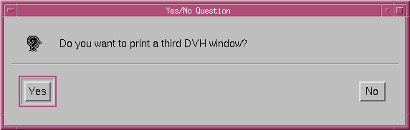

- If the third DVH plot is needed press Yes.
- The same Warning Message window will appear indicating a five second delay. Once you press Ok, click ONCE in the gray area beneath the scroll bar.
- After the five seconds, the screen will refresh and the mouse ‘arrow’ will morph into the mouse ‘eyeball’. Mouse click anywhere within the DVH viewing window when this occurs.
- A Yes/No Question window will appear indicating that the report requires 1 page. Press YES to continue.
- A Yes/No Question window will appear to initialize printing of a misc. viewing window once the third DVH viewing window is finished printing.

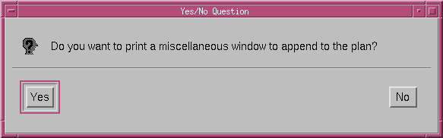

NOTE: This window can be used to print a fourth DVH plot if needed, additional DRRs, or any other information you wish to include in the plan.

- If a miscellaneous window is needed press Yes. If not, press No and skip steps 29-30.
- When the mouse cursor changes from an ‘arrow’ to an ‘eye’ click anywhere in the miscellaneous viewing window.
- A Yes/No Question window will appear indicating that the report requires 1 page. Press YES to continue.
- A Yes/No Question window will appear asking if you want to delete the newly created PDF file. It is recommended that you press Yes in order to keep the home folder on the pinnacle stations clear of clutter.

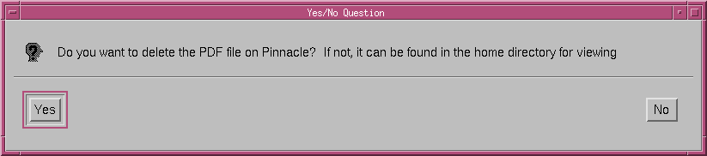

Note: Even if you press Yes to delete the PDF plan, it can be still be viewed on the remote server it was transferred to.

